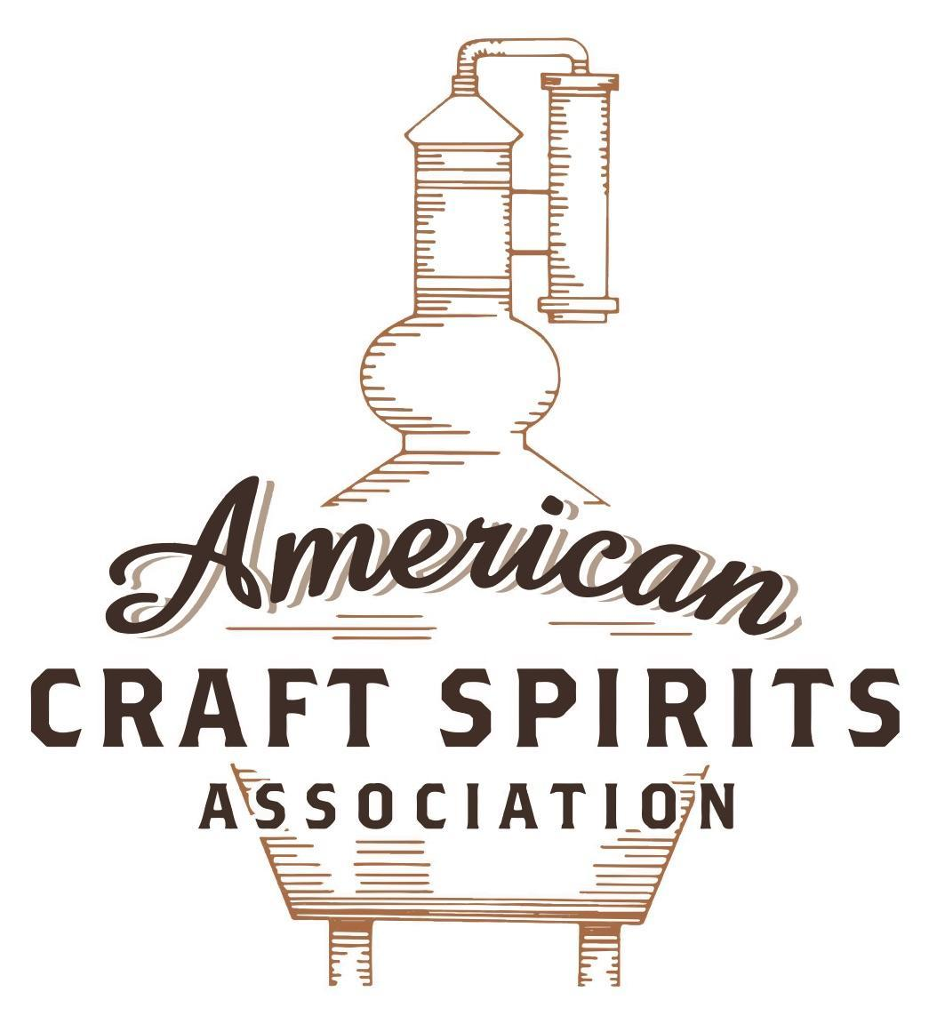
Spirits DtC Shipping Guide

This guide summarizes the direct-to-consumer shipping rules for distilleries in all 50 states and D.C. and also addresses the measures state governments have taken to ease delivery and shipping restrictions during the COVID-19 pandemic.

DtC Quick Guide Comparison

Out-of-State Distilleries  Can Ship Into State? |  |  |  | In-State Distilleries  Can Ship Within State?
State | Yes | No |  | State | Yes | No
AL |  | X |  | AL |  | X
AK | X |  |  | AK | X
AZ | X |  |  | AZ | X
AR |  | X |  | AR |  | X
CA |  | X* |  | CA |  | X*
CO |  | X |  | CO |  | X
CT |  | X* |  | CT |  | X
DE |  | X |  | DE |  | X
DC | X |  |  | DC | X
FL |  | X |  | FL |  | X
GA |  | X |  | GA |  | X
HI |  | X* |  | HI |  | ?*
ID |  | X |  | ID |  | X
IL |  | X* |  | IL |  | X*
IN |  | X |  | IN |  | X
IA |  | X* |  | IA |  | X*
KS |  | X |  | KS |  | X
KY | X |  |  | KY | X
LA |  | X |  | LA |  | X
ME |  | X* |  | ME |  | X*
MD |  | X |  | MD |  | X
MA |  | X |  | MA |  | X
MI |  | X |  | MI |  | X
MN |  | X |  | MN |  | X
MS |  | X |  | MS |  | X
MO |  | X |  | MO |  | X
MT |  | X |  | MT |  | X
NE | X |  |  | NE | X
NV |  | X* |  | NV |  | X
NH | X |  |  | NH |  | X*
NJ |  | X* |  | NJ |  | X*
NM |  | X |  | NM |  | X
NY |  | X* |  | NY |  | X*
NC |  | X |  | NC |  | X
ND | X |  |  | ND | X
OH |  | X |  | OH |  | X
OK |  | X |  | OK |  | X
OR |  | X |  | OR | X
PA |  | X* |  | PA |  | X
RI |  | X* |  | RI |  | X
SC |  | X |  | SC |  | X
SD |  | X |  | SD |  | X
TN |  | X |  | TN |  | X
TX |  | X |  | TX |  | X
UT |  | X |  | UT |  | X
VT |  | X |  | VT |  | X
VA |  | X |  | VA |  | X
WA |  | X* |  | WA | X
WV |  | X* |  | WV |  | X*

WI |  | X |  | WI |  | X
WY |  | X |  | WY |  | X

Notes:
*CA: If passed and signed into law, Senate Bill 620 would allow licensed distilled spirits producers in states other than California and licensed distilled spirits manufacturers or craft distillers in California who obtain distilled spirits direct shipper permits to ship directly to consumers in California
*CT: Consumers with appropriate permit may receive alcohol shipments
*HI: Consumers with appropriate permit may receive alcohol shipments; If passed and signed into law, Senate Bill 65 would allow licensed distilled spirits manufacturers in Hawaii and in states other than Hawaii who obtain direct shipper permits to ship directly to consumers in Hawaii
*IL: If passed and signed into law, Senate Bill 0532 would allow licensed distilled spirits producers in Illinois and in states other than Illinois who obtain distillery shippers’ licenses to ship directly to consumers in Illinois
*IA: If passed and signed into law, House File 639 would allow native distilled spirits manufacturers in Iowa and in states other than Iowa who obtain direct shipper permits to ship directly to consumers in Iowa and to consumers in states other than Iowa
*ME: If passed and signed into law, Legislative Document 1358 would allow distilleries outside of Maine with current manufacturer licenses and distilleries licensed in Maine who obtain spirits direct shipper licenses to ship directly to consumers in Maine
*NJ: (1) If passed and signed into law, Assembly Bill 3167 would allow a craft distillery licensees to ship no more than 9 liters of distilled spirits to a consumer in New Jersey; (2) If passed and signed into law, Senate Bill 3020 would allow craft distillery licensees in New Jersey or in states other than New Jersey to ship no more than 20 liters of distilled spirits to a consumer in New Jersey via common carrier
*NV: Licensed individuals can import one gallon per month of spirits for personal use and the out-of-state supplier must pay excise tax
*NH: If passed and signed into law, Senate Bill 125 would allow licensed liquor manufacturers who obtain direct to consumer shipping permits from the commission to ship directly to consumers in New Hampshire
*NY: Consumer may import up to 90L of liquor per year for personal use without a license; If passed and signed into law, Assembly Bill 3275 would allow licensed liquor manufacturers in states other than New York and licensed distillers and farm distillers in New York to ship no more than thirty-six cases (no more than nine liters per case) of liquor to consumers in New York
*PA: Consumer may place a special liquor order and distiller must ship to a PLCB-operated store
*RI: Distiller can only ship to customer if order was personally placed by customer at distiller's premises
*WA: If passed and signed into law, House Bill 1432 would allow licensed spirits manufacturers in states other than Washington to ship spirits to consumers in Washington
*WV: Distilleries, mini-distilleries, or micro-distilleries licensed in West Virginia or a state other than West Virginia who obtain private direct shipper licenses to ship to a consumer in West Virginia, however the shipments must be made to a retail liquor outlet

MINNESOTA
Shipment Outbound – Silent.
Shipment Inbound – No, all alcohol must be shipped to a licensed wholesaler's warehouse (Minn. Stat. 340A.3021).
Shipment Intra-state – No, microdistilleries may be issued a license to sell alcohol for off-premises consumption (Minn. Stat. 340A.22).
COVID-19 Measures – Places of Public Accommodation, including micro distiller cocktail rooms, are encouraged to offer food and beverage using delivery service, window service, walk-up service, drive-through service, or drive-up service. Establishments are encouraged to continue utilizing these precautions to mitigate the potential transmission of COVID-19 even after June 10. Although distilleries and micro distiller cocktail rooms may provide indoor and outdoor service if they adhere to the applicable guidance available on the Stay Safe Minnesota website, Emergency Executive Order 21-11, signed on March 12, 2021, encourages Places of Public Accommodation to continue to offer food and beverages using delivery services, window service, walk-up service, drive-through service, or drive-up service.
Emergency Executive Order 20-74 Link:
https://mn.gov/governor/assets/EO%2020-74%20Final_tcm1055-437539.pdf (June 5, 2020)
Emergency Executive Order 21-11 Link:
https://mn.gov/governor/assets/EO%2021-11%20Final_tcm1055-472034.pdf (March 12, 2021)
Citation (shipment)
Minnesota Statutes
340A.22 MICRODISTILLERIES.
Subd. 4. Off-sale license. A microdistillery may be issued a license by the local licensing authority for off-sale of distilled spirits, with the approval of the commissioner. The license may allow the sale of one 375 milliliter bottle per customer per day of product manufactured on site, subject to the following requirements:
(1) off-sale hours of sale must conform to hours of sale for retail off-sale licensees in the licensing municipality; and
(2) no brand may be sold at the microdistillery unless it is also available for distribution by wholesalers.
Link: https://www.revisor.mn.gov/statutes/cite/340A.22
340A.3021 IMPORTATION RESTRICTIONS.
Subdivision 1. Delivery to wholesaler only. (a) No person may consign, ship, or deliver alcoholic beverages to any place in Minnesota except to a licensed wholesaler’s warehouse, if the alcoholic beverages:
(1) were manufactured outside Minnesota; and
(2) have not previously been unloaded into a licensed wholesaler's warehouse in Minnesota.
(b) No person may ship or consign into Minnesota any alcoholic beverages manufactured outside the state unless the alcoholic beverages are continuously in the possession of a motor carrier of property as defined in section 221.012, subdivision 27, or a common carrier as defined in section 218.011, subdivision 10, or are carried in a motor vehicle owned, leased, or rented by a wholesaler licensed under this chapter, between the time the alcoholic beverages are introduced into Minnesota and the time they are unloaded into a licensed wholesaler's warehouse.
Link: https://www.revisor.mn.gov/statutes/cite/340A.22

The American Craft Spirits Association (ACSA) is working diligently to give our members and industry partners relevant, current updates on statutes and regulations impacting production, sale and distribution of spirits. With the declaration of the novel coronavirus (COVID-19) in early 2020, many states have issued temporary policy changes or longer-term modernization of alcohol beverage laws. State statutes, regulations created by the state alcohol regulatory authority, as well as any other relevant guidance provided by such authorities (such as advisories, opinions, bulletins, etc.) were reviewed in creation of this document. No city or county ordinances were reviewed. Distillers should be aware that even in states where direct shipping is permissible, always remember to avoid shipping to dry counties. Please consult with your state guild or alcohol beverage authority for the most up-to-date information. This content is intended for educational and informational purposes only. ACSA's pro bono law firm of Malkin Law P.A. provided the core content found in this comprehensive overview of the spirits distribution after COVID-19. It was completed in August 2021 and will be updated regularly. If you have updates you would like to provide, please send to legislation@americancraftspirits.org or directly to the law firm at: ryan@malkin.law / malkin.law. Thank you.

